STATE SCIENCE AND TECHNOLOGY PROGRAMME (SSTP)

SECRETARIAT ASSISTANCE FOR THE DEVELOPMENT OF STATE S&T COUNCILS

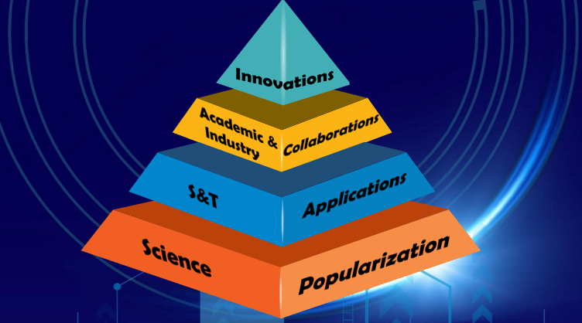

GOVERNMENT OF INDIA
DEPARTMENT OF SCIENCE AND TECHNOLOGY
MINISTRY OF SCIENCE AND TECHNOLOGY
TECHNOLOGY BHAVAN,
NEW MEHRAULI ROAD
NEW DELHI-110016

FORMAT OF PROPOSAL SUBMISSION FOR THE FINANCIAL YEAR 2021- __

SUMMARY SHEET

- Name of the State:
- Name of the State S&T Council:
- Address of the S&T Council:
City:
PIN:
Email:
Phone (O):
Website:

- Name of Chief Administrative Authority :
Designation:
Email:
Mobile Number:
Phone (O):

- Name of Nodal Chief Executive Officer:
Designation:
Email:
Mobile Number:
Phone (O):

- Year of Establishment of State S&T Council:

- Vision of State S&T Council to catalyze State level Science, Technology and Innovation (STI) Ecosystem.

- Mission of State S&T Council:

- Objectives of State S&T Council:

- Financial Outlays/Budget (Rs. Lakhs) of Organization for last Five Years
Particulars | FY 2016-17 | FY 2017-18 | FY 2018-19 | FY 2019-20 | FY 2020-21
Total State S&T Plan Outlay
Total Outlay for S&T Programmes/
Schemes
Total Outlay for Manpower Salary Component
- State’s share of total outlay for manpower salary component
ii) Share of other Ministry/Department, if any

- Budget Proposed for Supporting S&T Secretariat from Department of Science and Technology (DST), Government of India for current financial year

Budget Mobilization from other sources (other Ministry/ Departments/Agency)

- Documents to be Enclosed:

- Copy of State Government Notification Yes No
- Organogram of State S&T Council Yes No
- Composition of Governing Body Yes No
- Composition of Executive Body Yes No
- Composition of State S&T Council (Details of employees) Yes No
- Audited Statement of Expenditure for Last Five Years Yes No

- State Authority Approving the Proposal and Budget:

Name:
Designation:
Reference No:
Date:

Signature of Proposer:

Name:
Designation:
Date:

PART - I OF PROPOSAL
      - Role of State S&T Council in catalyzing Science Technology and Innovation (STI) Ecosystem in State
- words)

- Methodology Adopted to Attain the Goal to Catalyze STI in State
- State Prioritized Sustainable Development Goals (SDGs)
- Programmes /Schemes undertaken since Establishment of S&T Council (please fill Annexure I)
- Proposed Programmes /Schemes of State S&T Council to be undertaken during Current Financial Cycle
(2021-26)

S.No | Title of the Programme/Scheme (please provide acronym if any) | Programme/Scheme Summary | Duration of the Scheme/Programme  (Start Date and Completion Date) | Nodal Officer  (Name, Designation, Contact No) | Other associated Human Resource | Deliverables | Budget

- Experts /Specialists associated with the Programme/Schemes:

S. No. | Name | Designation | Institution (Full Address) | Central/State
1.
2.
3.

7. Sources/Allocation of Funds:
(Rs. in Lakh)

Sl. No. | Sources/Allocations of Funds | Budget Head | FY 2016-17 | FY 2017-18 | FY 2018-19 | FY 2019-20 | FY 2020-21 | Current Financial Year | Remarks
1. | Share of State S&T Council/Organization  (Expenditure/Proposed budget) | Recurring
 |  | Non Recurring
 |  | Sub-Total
2 | Share of DST,GoI (Expenditure/Proposed budget) | Recurring
 |  | Non Recurring
 |  | Sub-Total
3. | Other Sources  (Ministry, Department, Agency)  (Expenditure/Proposed budget) | Recurring
 |  | Non Recurring
 |  | Sub-Total
 | Total | (Sub-Total 1+2+3)

- Coordinated Programmes/ Individual Projects undertaken by the State S&T Council
(list to be enclosed as Annexure II)

Sr. No. | Coordinated Programmes/ Individual Projects | FY 2016-17 | FY 2017-18 | FY 2018-19 | FY 2019-20 | FY 2020-21 | Current Financial Year | Remarks
1. | (a) No. of Coordinated Programmes
 | (b) No. of projects under Coordinated Programmes
 | (c) Total expenditure/ Proposed budget for Coordinated programmes (Rs. in Lakh)
2. | (a) No. of individual Projects
 | (b) Total expenditure/ proposed budget for individual projects (Rs. in Lakh)

- List of Projects Funded in the State to Academic, R&D Institutes and Voluntary Organizations by the State S&T Councils in last 5 years including Budget Allocation

Annexure I

Programmes /Schemes undertaken by S&T Council since its Establishment

Sl. No. | Programme/Scheme Title | Starting Date of Scheme/Programme | Completion Date of Scheme/Programme | Budget Allocated (Rs. in Lakh) | Expenditure (Rs. in Lakh)

Brief Summary of Each Programme/Scheme (Highlighting Achievements, No. of Beneficiaries etc)

Annexure II

List of Individual Projects/Programmes

S.No. | Project Title | PI & Institution  (full address) | Sanctioned amount | Amount released | Date of start | Date of completion | Remarks

PART- II OF PROPOSAL

S&T Secretariat to State Science & Technology Council

1. Details Required

S. No. | Topic
1. | Approved Positions
2. | Personnel Recruitment Rule of the State S&T Council (please enclose the established guidelines)
3. | Personnel Policy of the State Government
4. | Promotion Policy of the State S&T Council
5. | Transfer policy of Staff

2. State S&T Council’s Secretariat Deployment Pattern

S.No. | Scheme/Programme | State S&T Council Official | Designation | Pay Scale | Highest Qualification (Attach Details*) | Remarks

*Essential/desirable.

3. Utillization of Human Resources:

S. No. | Name and Designation of Official of S&T Council | Current Role and Responsibilties | Engagaement of official with schemes/programmes/projects (name/ title) in last 5 years

4. PROPOSED BUDGET FOR SECRETARIAT FOR CURRENT FINANCIAL YEAR : 20__- 20__

(Rs. In Lakhs)

S.No. | Item | Share of DST, GoI | Share of State Grant | Total
A | RECURRING EXPENDITURE
I. Manpower Salary
a)
b)
c)

Sub Total-

II. Travelling & Daily Allowance

III. Consumables
IV. Other Items
a)
b)
c)

Sub Total

TOTAL (Recurring Expenditure)
B | NON- RECURRING EXPENDITURE  (Equipment etc.)  (Item wise with cost )  a)  b)  c)  TOTAL (Non – Recurring Expenditure)
 | GRANT TOTAL (A+B)

5. List of Human Resources whose Salary to be Paid from the Budgetary Support from State Science and Technology Programme (SSTP) of DST, GoI:
Sl. | Name | Designation | Qualification | Basic Pay | App. Monthly Emoluments
1
2
3

6.List of Human Resources whose salary to be paid from State Grant:
Sl. | Name | Designation | Qualification | Basic Pay | App. Monthly Emoluments
1
2
3

Signature of the Head of the State S&T Council

